NIGHT ROGAINE

LOCATION: (Note map on page 4)
This activity is undertaken in the area in close proximity of the buildings at Nayook Outdoor Education Centre.
DESCRIPTION:
This activity is normally completed as a precursor to the half day rogaine completed later in the camp. It is a useful session to complete as a night activity and can be completed in conjunction with a quiz or some other evening pursuit. Students need to have a clear understanding of the safety procedures and boundaries, all markers however are in close proximity to the main buildings.
AIMS;
- Students to gain the skills required to complete a basic rogaine course
- That students will successfully cooperate and organize themselves in small groups to compete a series of activities.
LEARNING OUTCOMES:
- To introduce to students the basic skills of navigation to find markers in easy conditions.
- To operate in small groups to solve a series of puzzles and quizzes in conjunction with the night rogaine.
AGE SUITABILITY:
This activity is suitable for students from Year 6 upwards
STAFF/STUDENT RATIO:
This session is conducted with one Nayook staff and one trainee with up to 25 students.
NB – There are never more that eight students outside on the night rogaine course at any one time.

Ratios: 1:10 (DEECD guidelines for orienteering))
INSTRUCTOR EXPERIENCE:
- The instructor needs to have good map interpretation skills and be very familiar with the area.
- The instructor needs to have a clear understanding of the safety procedures for a potential emergency
ASSISTANT/S EXPERIENCE:
- The assistant needs to have a good knowledge of map and compass skills and be vey familiar with the area.
- The assistant/s need to be able to competently assist the instructor in an emergency and needs to have a good understanding of the emergency procedures.
PARTICIPANT EXPERIENCE:
- No experience is required.
INSTRUCTOR RESPONSIBILITY:
- Overall responsibility for all staff and students engaged with the activity
- Brief assistants/visiting staff on their role and the safety procedures.
- Organize emergency equipment for all staff.
- Ensure students have the appropriate personal and activity equipment.
- Brief participants on and ensure participants have required skills and knowledge of safety and emergency procedures.
- Instruct students on the skills required to participate on this activity.
ASSISTANT/VISITING TEACHER RESPONSIBILITY:
- Assist the instructor where possible.
- Monitor groups on the course.
- Assist groups with any emergency or navigation issues.
- Take over if the instructor becomes incapacitated.
PARTICIPANT RESPONSIBILITY:
- To follow instruction as outlined in the safety brief and lesson outline
- To be responsible for the rogaining and safety equipment
SAFETY, FIRST AID & ACTIVITY EQUIPMENT:
First Aid Equipment | Safety Equipment | Activity Equipment
- First Aid kit  - Student medication  - Student medicals (summary of known problems) | - Mobile Telephone  - Emergency Numbers list  - Hand radio | For Students:  - Maps (NB appendix)  - Compass  - Whistle  - Control Card (NB appendix)  - Puzzle and quizzes  - Recording sheets  - Pencils  For staff:  - Master maps (NB appendix)
PARTICIPANT CLOTHING & EQUIPMENT:
Winter/Cold weather requirements | Summer/hot weather requirement
- WW Jackets  - Suitable footwear  - Suitable clothing for the weather conditions  - Personal medication | - Long pants (for snakes)  - Suitable clothing for weather conditions)  - Suitable footwear (no thongs)  - Personal medication
SAFETY BRIEFING:
- When outside the group must at all times stay together; if students become separated they must immediately head back to the dining room.
- If an injury occurs alert Nayook staff.
- Discuss boundaries; no-one is to climb through any fences, cross 4WD tracks or bitumen roads
- No running; there are too many tripping/falling hazards.
- Do not interfere with any wildlife.
- In the warmer months be aware of snakes; long pants might be worn, if found let Nayook staff know.
EMERGENCY PROCEDURES:
- At least one staff member should be outside at all times.
- If a student or group of students are lost, one staff member to remain at the camp with the group.
- Available staff to walk the area and try and find where last sited. One staff member should walk the boundary of the course.
- If an injury, treat and evacuate if appropriate.
- Call for extra assistance from off duty staff if necessary.
- Contact the Principal/Assistant Principal or the nominated emergency contact person (Note emergency call list in appendix).
- Call 000 (Police and/or ambulance as required).

ACTIVITY NOTES:
The following is the suggested plan for the night rogaine session. If deviating markedly from this then staff must notify the Director.
PRIOR TO SESSION:
- Brief assistants and/or visiting staff as outlined in the “Assistant/visiting staff responsibilities”, “Safety Briefing” and “Emergency Procedures”.
- Organize all maps, quizzes and puzzles for the session.
- Arrange the tables, suitable for a small group activity.
- Draw a table on the white board for the group competition (NB example below))
BRIEFING:
Topics to be covered:
- Discuss the objectives and challenges of the session including the use of puzzles and quizzes as part of the activity.
- Discuss the safety issues and emergency procedures (as outlined above under “Safety Briefing”).
- Remind and check that students have the appropriate personal equipment.
- Hand out the activity equipment and discuss the use and care of.
- Discuss map orientation by using features; buildings, tracks, fences, gardens etc.
- Interpreting; legend and scale (including an introduction to pacing).
- What markers to look for and how to mark the control card.
- Explain the scoring system (Points deducted for late return).
- Introduce the quizzes and puzzles that members of the group undertake while other members are on the course. (Note list of suitable activities in the appendix)
END OF SESSION:
DEBRIEFING:
- Undertake a brief discussion on success or otherwise of the session.
- Debriefing should address the objectives and can be discussed in light of the large rogaine at the end of the program.
- Total up scores and compete awards as appropriate.
CLEANUP:
Attend to the following items:
- Equipment – Collect all borrowed equipment and check for damage.
- Arrange for any missing controls to be replaced or repaired.
- Information - relay any appropriate information regarding students to; Director, Staff, Main School (If necessary) & Parents (If necessary).
RISK MANAGEMENT:
Staff must review risk management document prior to each session.

Example Table for Rogaine and Quiz Competition

 | Rogaine | Quiz | Scavenger  Hunt | Total Score
Group 1
List Names

Group 2
List Names

Group 3
List Names

Group 4
List Names

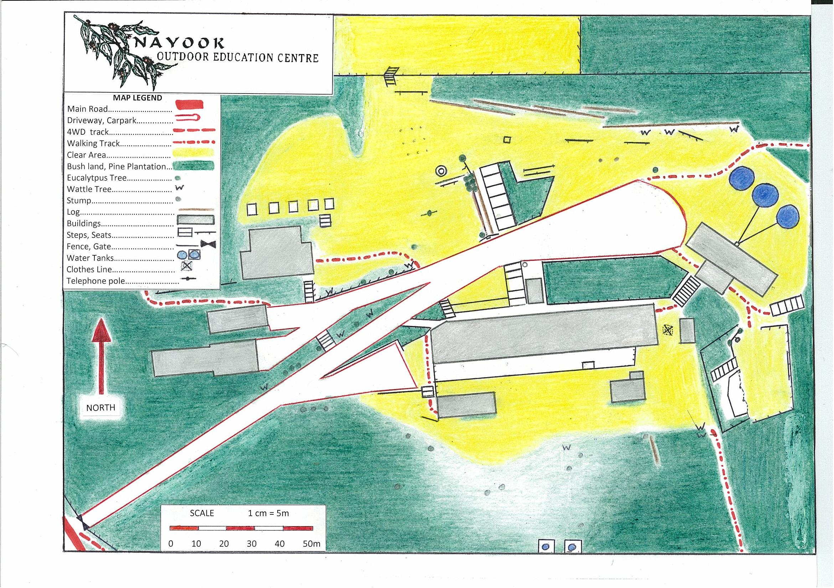
Night Rogaine Risk Assessment

Risk Assessment
This page is used to be more specific about each of the hazards identified, to review the existing safety controls and to assess the risks they pose.

Haz No | Hazard | Hazard Details | C | L | RR | Planned Controls
1 | People | Lost students | M | M | M | Instruct students thoroughly on the skills required to complete the course.  Ensure students have a thorough understanding of lost procedure.  Ensure staff are on the course to monitor and assist students at all times.  Ensure students clearly understand the boundaries for this activity.
2 | Emergency Plans | Evacuation in case of bush fire, injury etc | M | L | L | Check Weather Forecast for the week on the Bureau of Meteorology website. (www.bom.gov.au)  Review and implement plan for high fire risk days.  Modify program if conditions warrant it.  Ensure evacuation vehicles are available at short notice.
3 | Heat / Cold Stress | Dehydration, hypothermia | M | L | L | Ensure that all participants have warm clothing and a waterproof jacket in the colder months.  Modify the program if very cold and wet and students don’t have adequate protection.  Possibly shorten the activity if the heat warrants it.  Ensure adequate hydration students to carry full water bottles.
4 | Sensitised Response | Bee sting, allergic reaction to food | H | L | M | Carry anti- histamine, Epipen if student has a known allergy. Have ready access to Stingose and an ice pack. Be alert to students at risk (check medical forms).
5 | Animal | Snake Bite | H | L | M | Instruct students on appropriate behaviour on sighting snake.  Ensure students wear appropriate footwear and clothing during high risk times.  Ensure students understand emergency procedures if a bite occurs.  Instruct students on basic first aid if a bite occurs.  If a snake inhabits areas close to buildings a snake removalist should be contacted.

Haz No |  | Hazard | Hazard Details |  | C | L |  | RR | Planned Controls
6 |  | Area where slips, trips & falls occur | Ankle injuries, abrasions etc |  | H | H |  | H | Instruct students to move carefully (no running) at night and ensure they have access to a good torch.  Highlight areas on the course that students need to take extra care.  Appropriate footwear must be worn, no thongs or open type sandals.
7 |  | Medical | Medical Emergency |  | H | L |  | M | Ensure that all students have provided parent permission forms.  Staff need to review medical forms to identify students at risk.
8 |  | Trees | Falling Branches |  | H | L |  | M | In high wind conditions do not allow students around trees.  If conditions warrant it, change the activity.  Staff to undertake regular checks of dangerous trees or limbs, report to the relevant person for action.
* | C – consequences |  |  | L – Likelihood |  |  | RR – Risk Rank = C x L
L = Low M =Medium H = High VH = Very High E = Extreme
Actions to be taken as a result of assessment
Risk Rank | Action
Low | An incident or injury highly unlikely to occur
Medium | An accident or injury is possible staff need to supervise and be aware of safety and emergency procedures
High | Constant and careful supervision is required at all times.  Staff must be well trained for the activity and have a thorough knowledge of all safety and emergency procedures
Very High | Consider making changes to this activity as likelihood and consequences of an accident or injury are serious.
Extreme | The consequences and likelihood of accident or injury with this hazard/s ensure that this activity should not run in its present form

